
Niagara Irrigation Initiative Project

Notice of a Public Information Centre
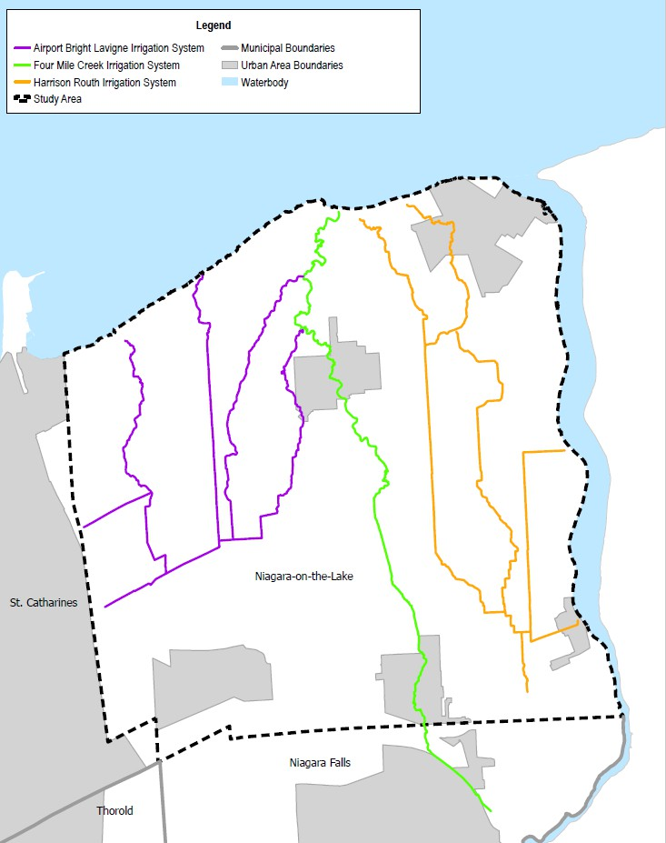
Upgrading and Enhancing Irrigation Infrastructure in the Town of Niagara-on-the-Lake
Map of Project Area

Project Background
Part of the broader Niagara Irrigation Initiative, this project is working towards upgrades and enhancements to the existing irrigation system in the Town of Niagara-on-the-Lake. Additional capacity in the system is required to meet current water demand, improve drought resilience, and to plan for the future.
To date, the Project Team has reviewed key background and design reports, conducted multiple site visits, released a user survey, consulted extensively with the Town’s Irrigation Committee, and drafted a Consolidated Engineering Report, which includes several design alternatives. Based on a technical evaluation and feedback, the Project Team has recommended four solutions to proceed to the detailed design phase.

Join Us – Your Input is Important
The Project Steering Committee, supported by Niagara Region and the Town of Niagara-on-the-Lake Staff, and the Project Consulting Team, is hosting a Public Information Centre to answer questions and seek feedback about the project.

Wednesday, June 10, 2026 – 6:00 to 8:00 p.m. (Drop-in anytime) Niagara-on-the-Lake Community Centre: Mori Room
14 Anderson Lane, Niagara-on-the-Lake, Ontario
All members of the public are invited to attend, learn about irrigation in the Town of Niagara-on-the-Lake, get a project update, and provide feedback on the detailed design process. This Public Information Centre will be a drop-in style event and will feature display boards with multiple subject matter experts available for questions. Materials will also be available on the project webpage following the event: https://www.niagararegion.ca/projects/irrigation-initiative/

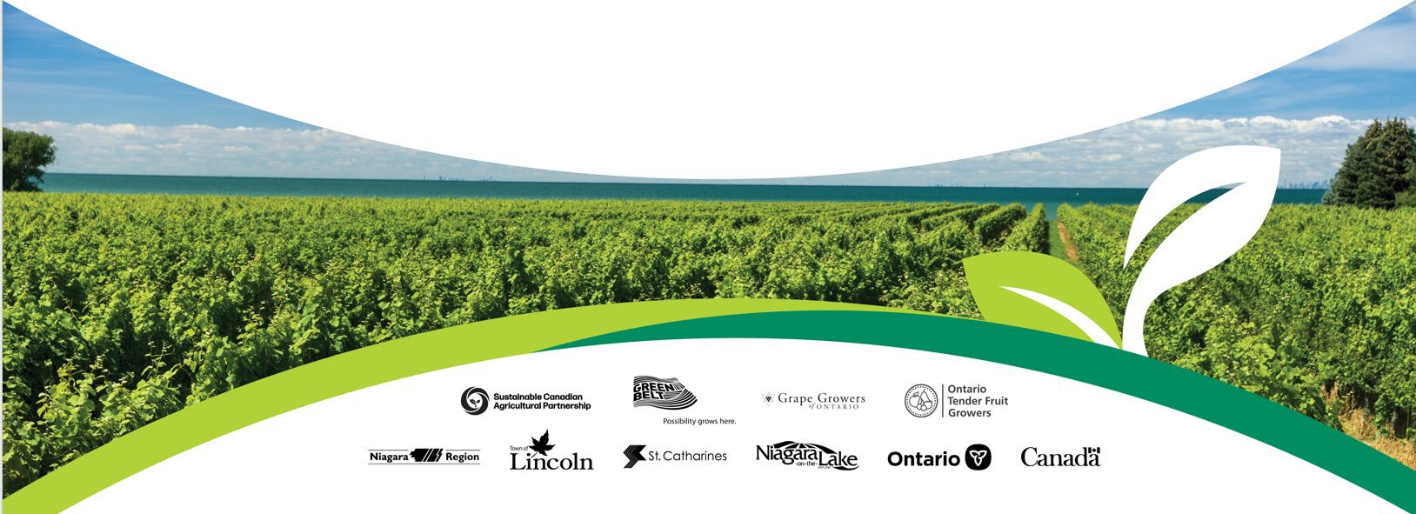
Contact Us
If you are interested in providing feedback on the project but cannot attend, please e-mail us at: irrigation@niagararegion.ca. For additional information, or if you require accessibility accommodations or materials in an alternate format to participate in meetings or events, please contact:
Sean Norman, PMP, MCIP, RPP
Manager, Strategic Initiatives, Niagara Region 905-980-6000, extension 3179 sean.norman@niagararegion.ca
Requests for accommodations should be made in advance to allow sufficient time for arrangements.

Any personal information submitted will be collected, used and disclosed, where applicable, by members of Regional staff according to the Municipal Freedom of Information and Protection of Privacy Act (MFIPPA). Any information you share will onlybe used for the intended purpose for which it was provided. For questions or comments about privacy practices, or for more information about the administration of the Municipal Freedom of Information and Protection of Privacy Act in Niagara Region programs see niagararegion.ca/government/foi.

This project is funded through the Sustainable Canadian Agricultural Partnership (Sustainable CAP) - a five-year $3.5-billion investment by federal-provincial and territorial governments.

